Rental Management System

CREATE TABLE owners(

owner_id INT PRIMARY KEY,

owner_name VARCHAR(20),

adress VARCHAR(20),

phone_no BIGINT,

email_id VARCHAR(30)

);

CREATE TABLE cars(

car_id INT PRIMARY KEY,

car_name VARCHAR(20),

car_type VARCHAR(20),

owner_id INT

);

CREATE TABLE customers(

customer_id INT PRIMARY KEY,

customer_name VARCHAR(20),

address VARCHAR(20),

phone_no BIGINT,

email_id VARCHAR(20)

);

CREATE TABLE rentals(

rental_id INT PRIMARY KEY,

customer_id INT,

car_id INT,

pickup_date DATE,

return_date DATE,

km_driven INT,

fare_amount DOUBLE(10,2)

);

-- owners table values

INSERT INTO owners VALUES(1001,'Sai','Sasikanth Nagar',9023894561,'sai123@gmail.com');

INSERT INTO owners VALUES(1002,'Lakshmi','Gandhi Nagar',9133734393,'lakshmi963@gmail.com');

INSERT INTO owners VALUES(1003,'Sowjanya','Pratap Nagar',9494469653,'sowjanya16@gmail.com');

INSERT INTO owners VALUES(1004,'Sidhardha','Ashok Nagar',9666023456,'Sidhardha@gmail.com');

INSERT INTO owners VALUES(1005,'Ram','Venkat Nagar',9848058589,'ram741@gmail.com');

-- cars values

INSERT INTO cars VALUES(911,'BMW','SIDAN',1001);

INSERT INTO cars VALUES(912,'AUDI','SIDAN',1002);

INSERT INTO cars VALUES(913,'MG','SUV',1003);

INSERT INTO cars VALUES(914,'BENZE','COMPACT SUV',1004);

INSERT INTO cars VALUES(915,'TATA','LOW SIDAN',1005);

--customer values

INSERT INTO customers VALUES(101,'Padmaja','kakinada',9847692563,'Padmaja@gmail.com');

INSERT INTO customers VALUES(102,'Srinivas','eluru',7419638520,'Srinivas@gmail.com');

INSERT INTO customers VALUES(103,'Surya','vijayawada',9637418520,'Surya@gmail.com');

INSERT INTO customers VALUES(104,'Pavitra','hyderabad',8529637410,'Pavitra@gmail.com');

INSERT INTO customers VALUES(105,'Sindhu','vizag',7893266541,'Sindhu@gmail.com');

--rentals table values

INSERT INTO rentals VALUES(11,101,911,'19-2-2022','25-2-2022',25,2500);

INSERT INTO rentals VALUES(12,102,912,'25-3-2022','01-04-2022',22,2300);

INSERT INTO rentals VALUES(13,103,913,'5-4-2022','14-4-2022',40,3500);

INSERT INTO rentals VALUES(14,104,914,'20-4-2022','30-4-2022',27,2700);

INSERT INTO rentals VALUES(15,105,915,'1-5-2022','16-5-2022',33,2950);

SELECT * FROM owners;

SELECT * FROM customers;

SELECT * FROM cars;

SELECT * FROM rentals;

**Output:**

Owners:

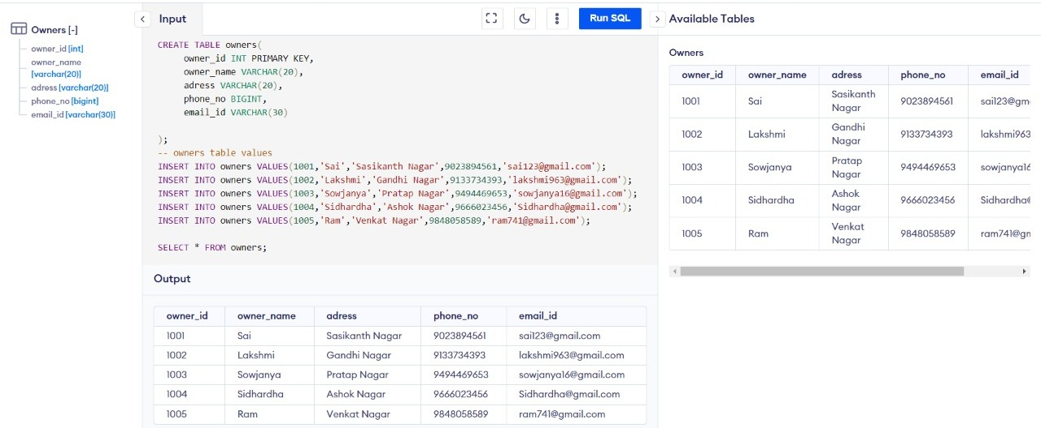

Customers:

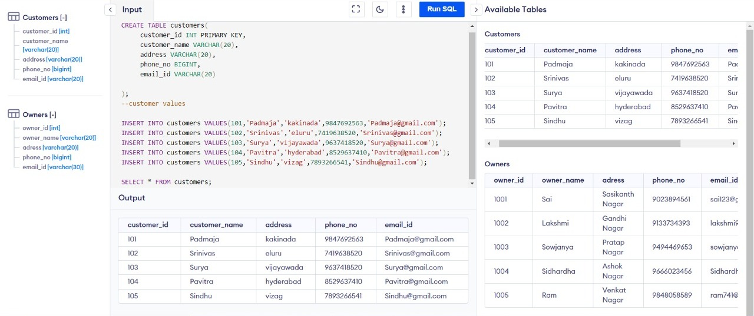

Cars:

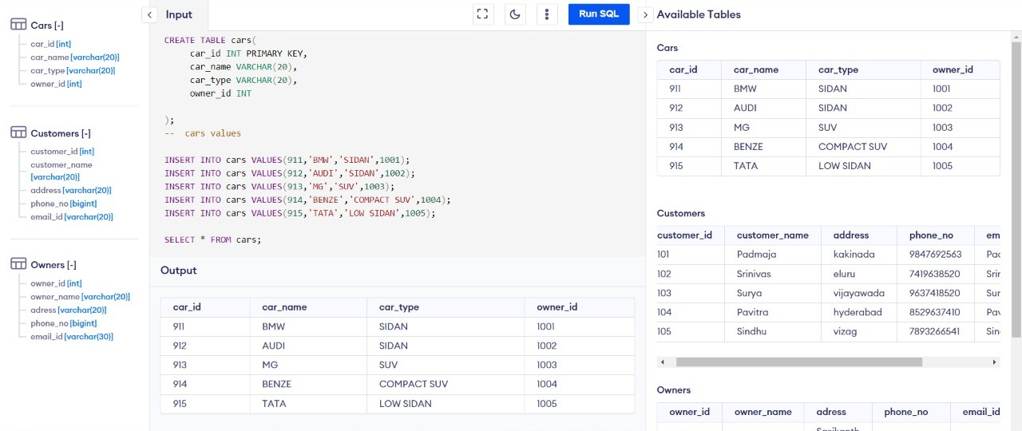

Rentals:

